Title - Arial 14 pt., bold, centered, 1.5 line spacing
Author(s), institution, city/country; underline presenting author
Arial 12 pt., italic, centered, 1.5 line spacing

Submissions should be 2 pages long (1 page text, 1 page images and citations, max. 1 MB, PDF document).
Authors may indicate their preferred form of presentation (lecture or poster); however, the program committee reserves the right to decide on the presentation format of individual contributions and to reject contributions that are unsuitable in terms of content.
Text - Arial 12 pt., justified, 1.2 line spacing

Language
The official language of presentations at the 18th DSS is German, but English-language contributions are also welcome. English is recommended for slides and posters to facilitate communication with international guests / PhD students.
Text - Arial 12 pt., justified, 1.2 line spacing

Subheading - Arial 12 pt., bold, left-aligned, 1.2 line spacing, 6 pt. space before.
Lorem ipsum dolor sit amet, consectetur adipiscing elit, sed eiusmod tempor incidunt ut labore et dolore magna aliqua. Ut enim ad minim veniam, quis nostrud exercitation ullamco laboris nisi ut aliquid ex ea commodi consequat. Quis aute iure reprehenderit in voluptate velit esse cillum dolore eu fugiat nulla pariatur. Excepteur sint obcaecat cupiditat non proident, sunt in culpa qui officia deserunt mollit anim id est laborum.
Lorem ipsum dolor sit amet, consectetur adipiscing elit, sed eiusmod tempor incidunt ut labore et dolore magna aliqua. Ut enim ad minim veniam, quis nostrud exercitation ullamco laboris nisi ut aliquid ex ea commodi consequat. Quis aute iure reprehenderit in voluptate velit esse cillum dolore eu fugiat nulla pariatur. Excepteur sint obcaecat cupiditat non proident, sunt in culpa qui officia deserunt mollit anim id est laborum.
Lorem ipsum dolor sit amet, consectetur adipiscing elit, sed eiusmod tempor incidunt ut labore et dolore magna aliqua. Ut enim ad minim veniam, quis nostrud exercitation ullamco laboris nisi ut aliquid ex ea commodi consequat. Quis aute iure reprehenderit in voluptate velit esse cillum dolore eu fugiat nulla pariatur. Excepteur sint obcaecat cupiditat non proident, sunt in culpa qui officia deserunt mollit anim id est laborum.
Lorem ipsum dolor sit amet, consectetur adipiscing elit, sed eiusmod tempor incidunt ut labore et dolore magna aliqua. Ut enim ad minim veniam, quis nostrud exercitation ullamco laboris nisi ut aliquid ex ea commodi consequat. Quis aute iure reprehenderit in voluptate velit esse cillum dolore eu fugiat nulla pariatur. Excepteur sint obcaecat cupiditat non proident, sunt in culpa qui officia deserunt mollit anim id est laborum.
Text - Arial 12 pt., justified, 1.2 line spacing

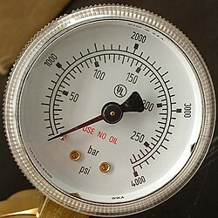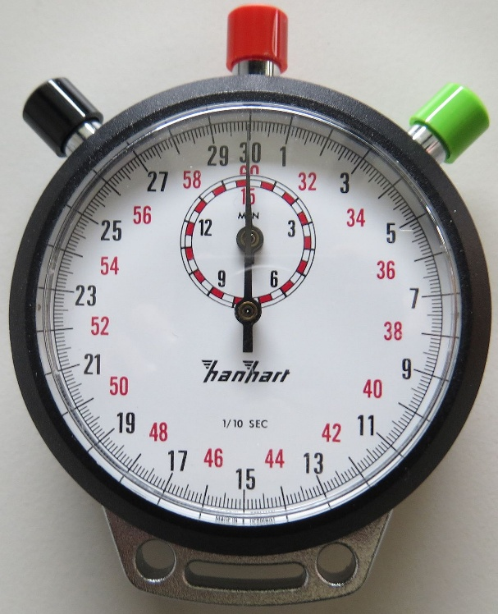
Figure 1: Analog pressure gauge [2] Figure 2: Stopwatch by Hanhart [3]
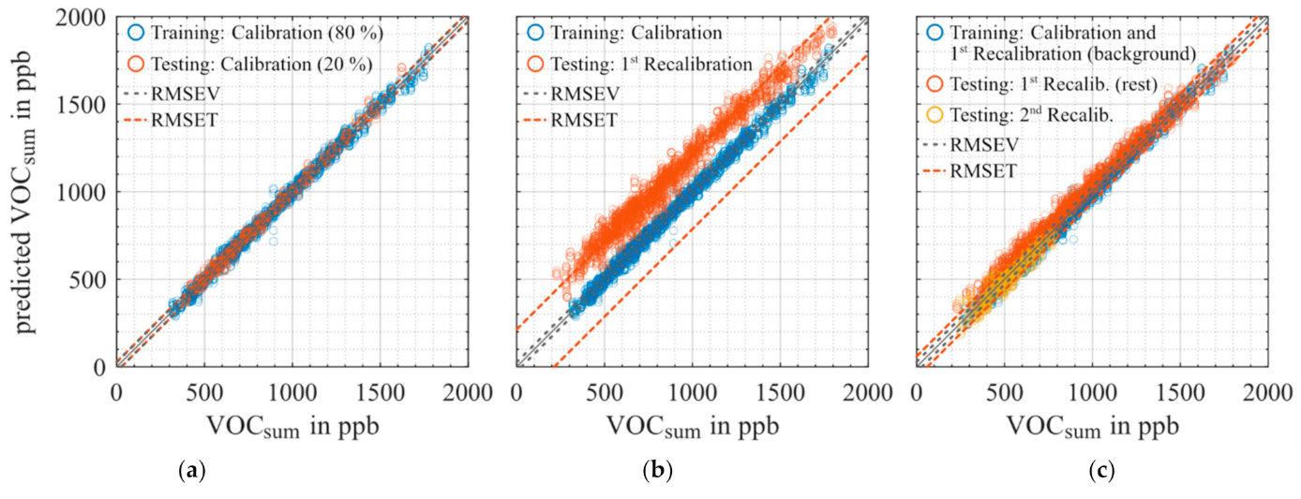
Figure 3: An example of a convincing measurement result [4]
Figure caption - Arial 11 pt., left-aligned, 1.2 line spacing

Citations
[1] A. Autor, B. Betor, C. Cator: Title of Cited Publication, Book or Journal (incl. issue, pages), year, DOI if possible
[2] Wikipedia.de: Keyword Analogmessgerät, Foto: Hey Paul from State College, PA, USA, CC BY 2.0
[3] Wikipedia.de: Keyword Stoppuhr, Foto: Stefan Pohl, gemeinfrei
[4] T. Baur, J. Amann, C. Schultealbert, A. Schütze: Field Study of Metal Oxide Semiconductor Gas Sensors in Temperature Cycled Operation for Selective VOC Monitoring in Indoor Air, Atmosphere 12, 647, 2021, DOI 10.3390/atmos12050647
[5] Quellen - Arial 10 pt., left-aligned, 1 line spacing, 3 pt. space before.

